**Docker Images Lab**

Time spent: 60 min

**Image creation from a container**

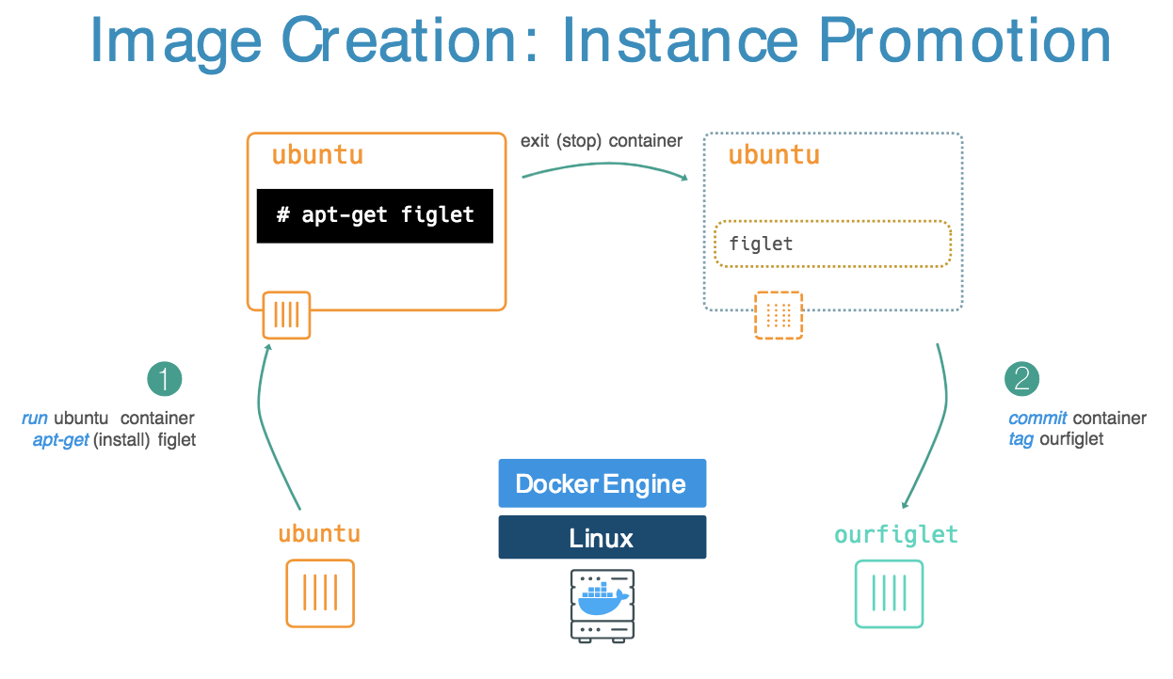

1.Run the figlet in the container

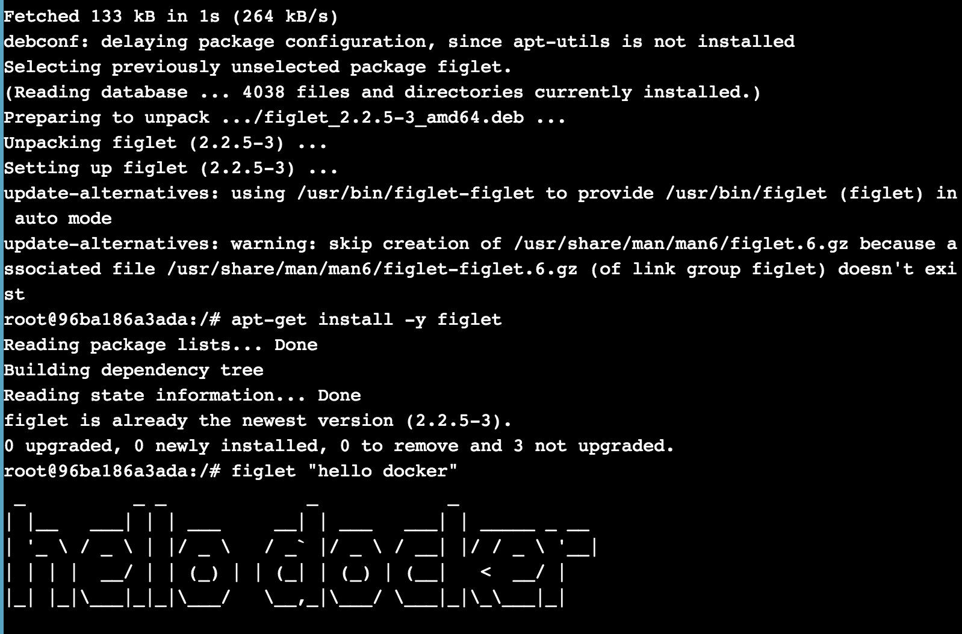

2.Commit the container

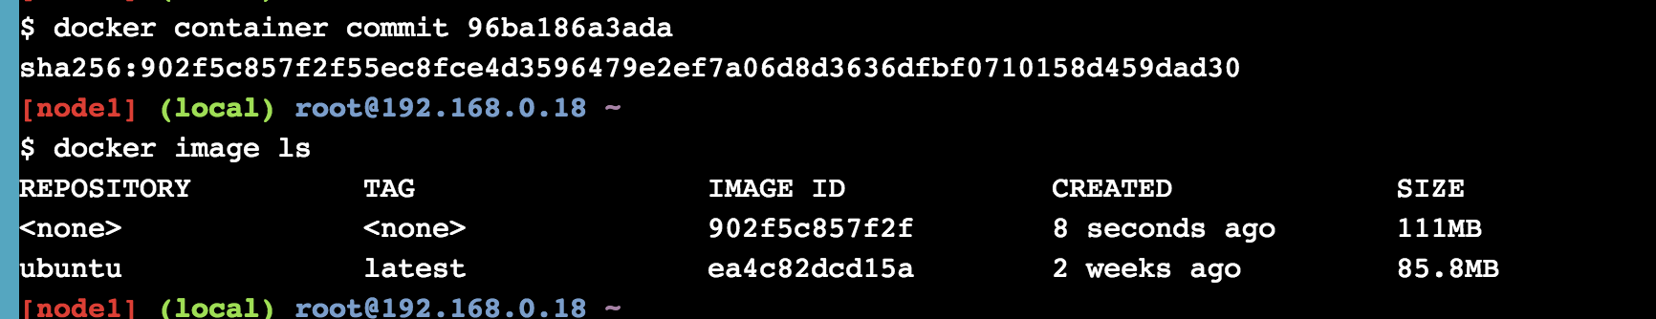

3.Rename the image

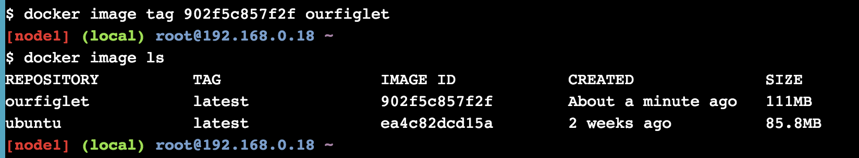

**Image creation using a Dockerfile**

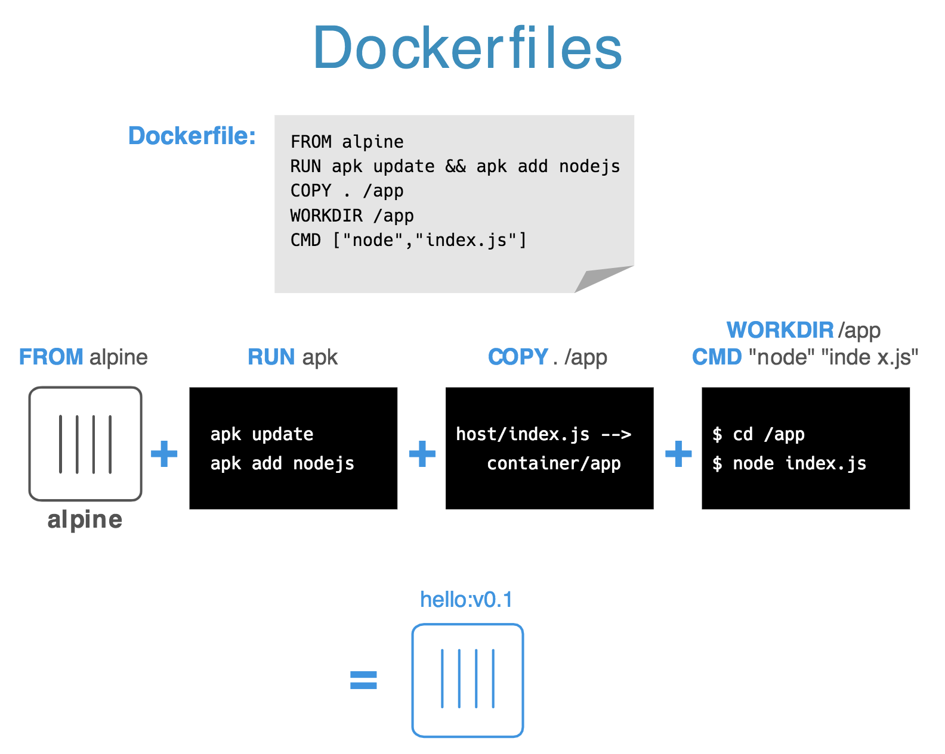

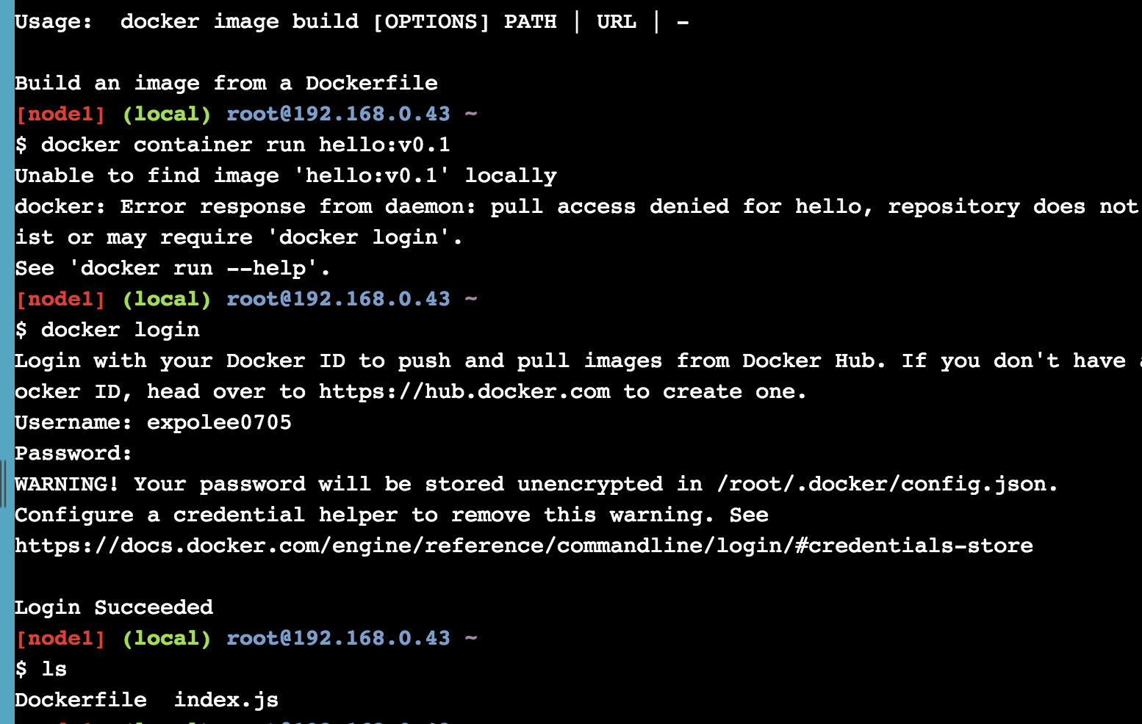

**Summary:**

In this Lab, I have learned the operation of the image in the containerand the image creation from dockerfile. Node.js also plays an important use in creating the image in the container.